

Duo application

Design document



Justice Dreischor

Kalina Atanasova

Class E-S34 (SM32)

Project Description

Our goal is to create a software solution for an application about events where the users can see the daily events in multiple cities in the Netherlands. As well as that they can take the position of hosts and should be able to create and maintain their own events. The attendants can then add reviews of the hosts and see the location of their friends.

Brainstorming Sessions

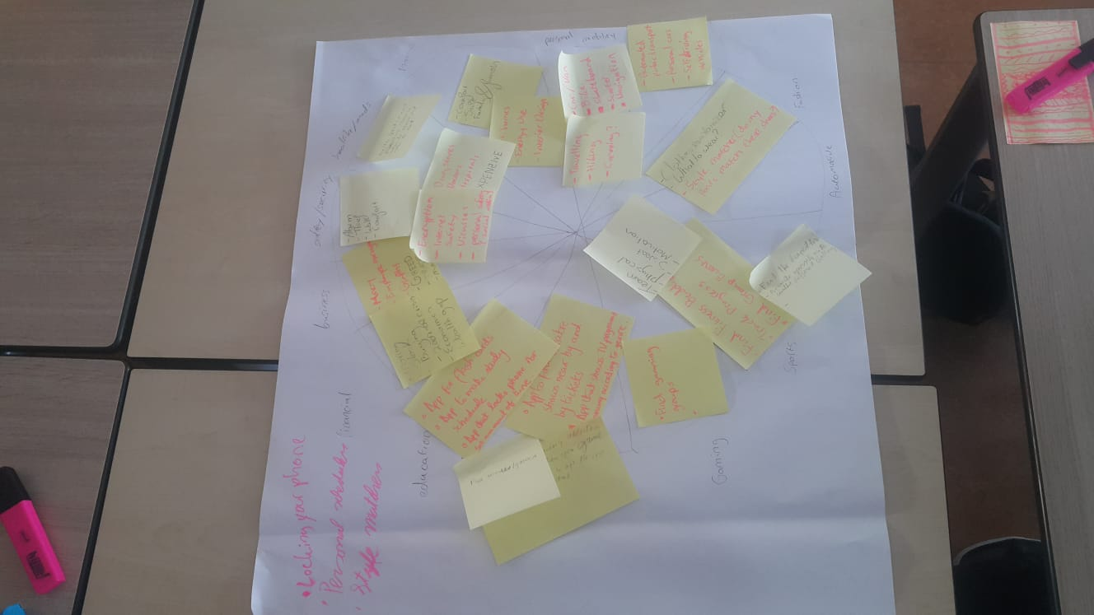

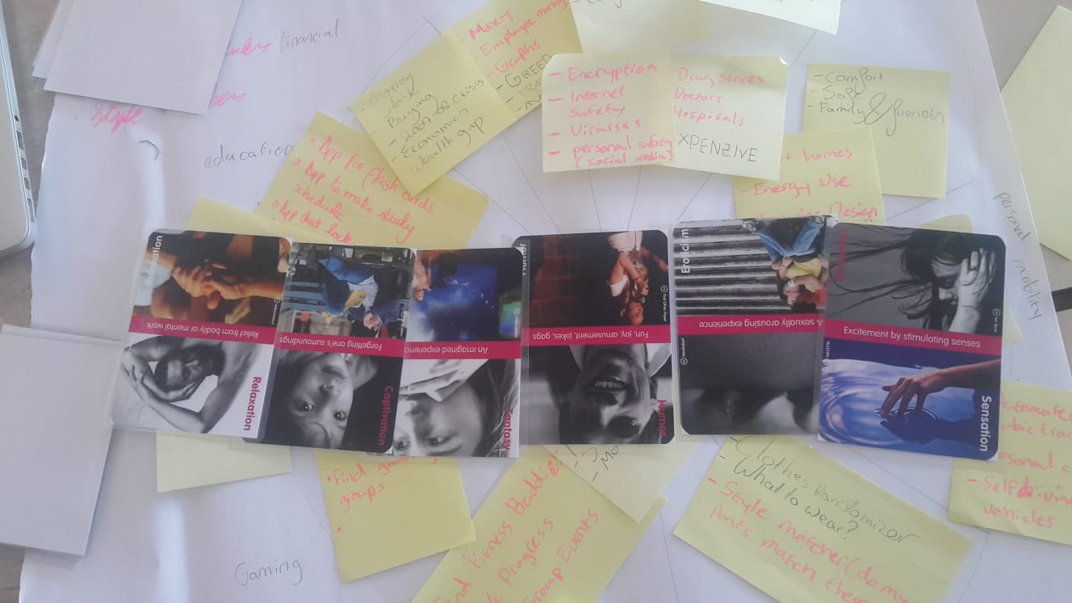

First Sketches

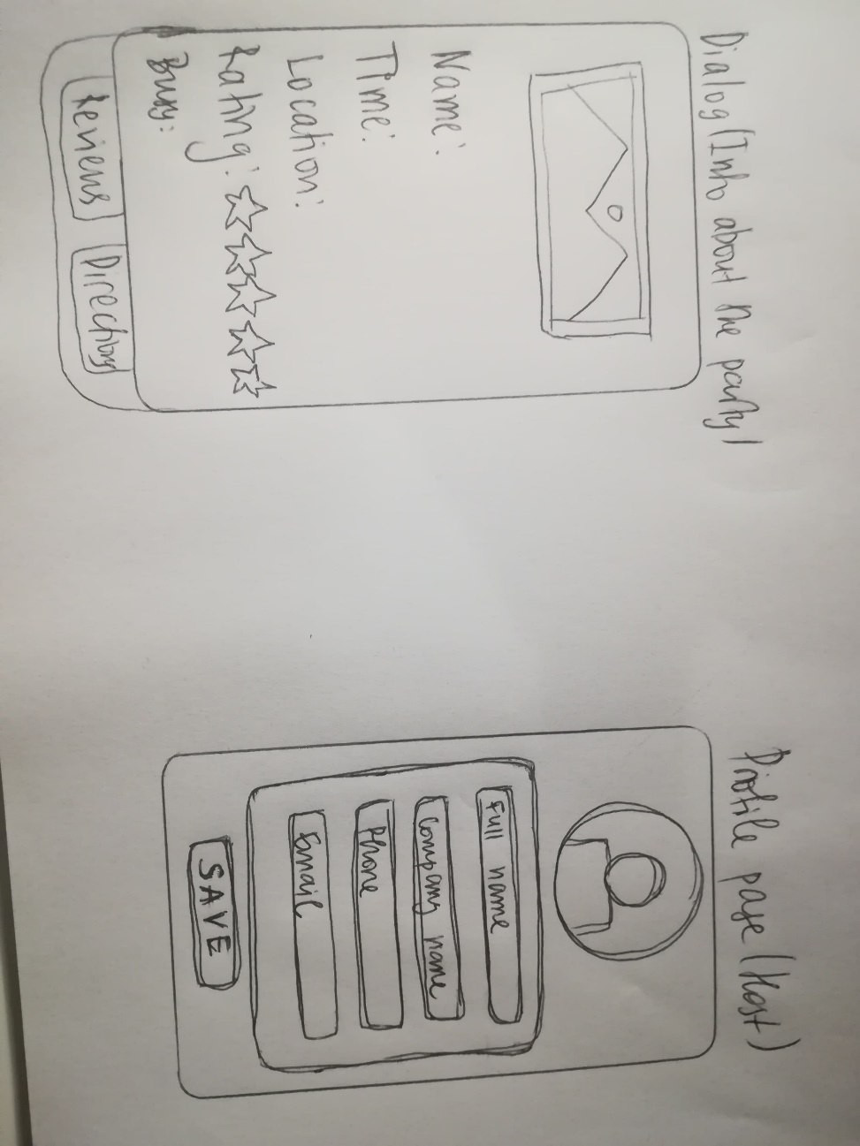

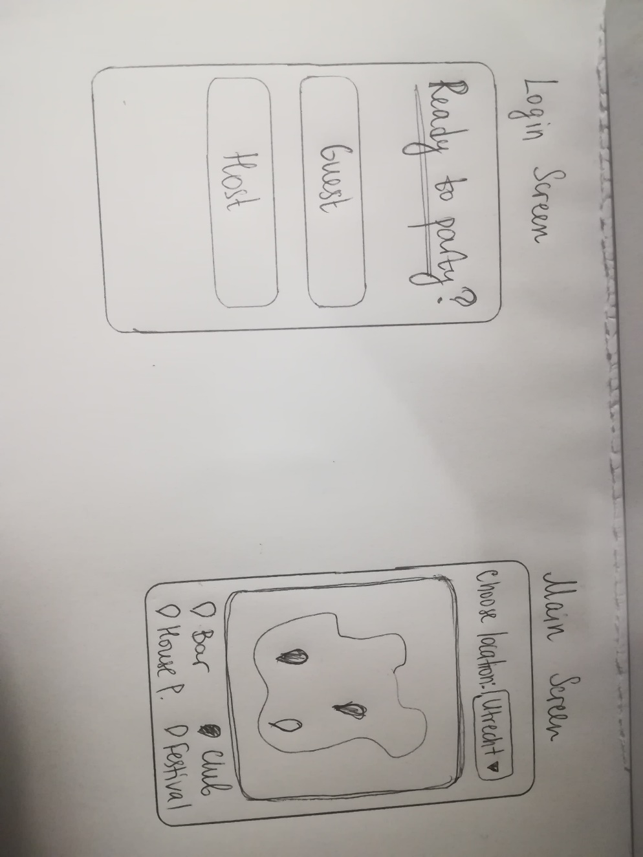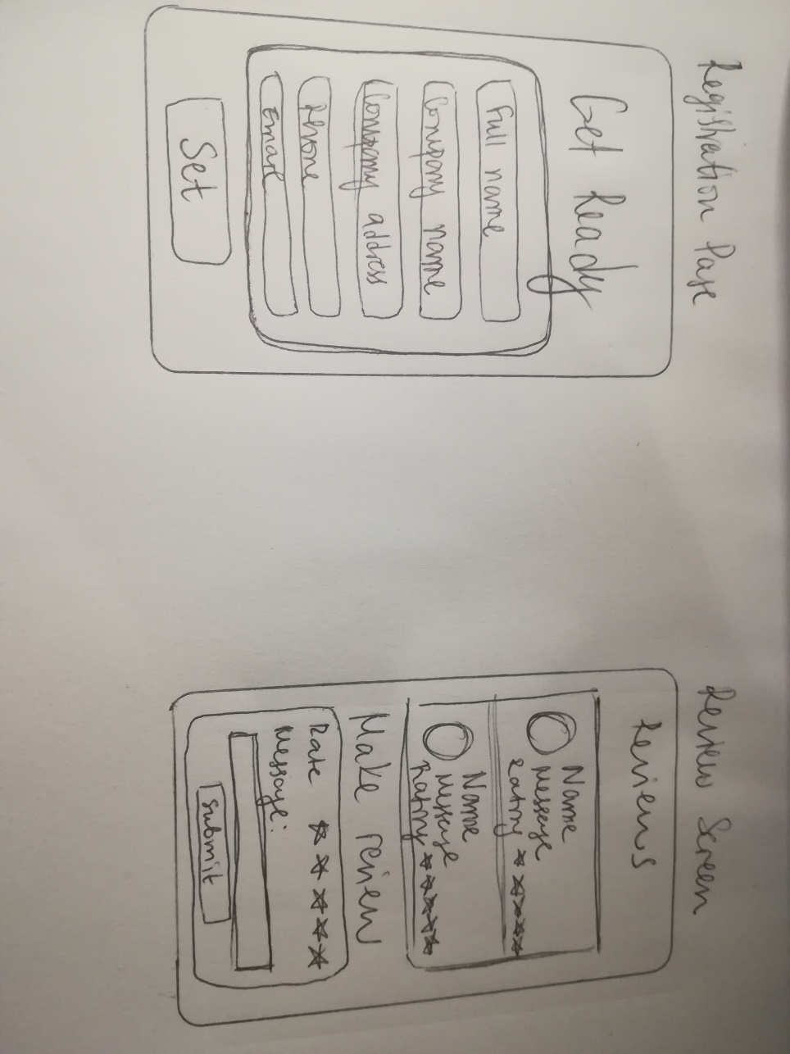

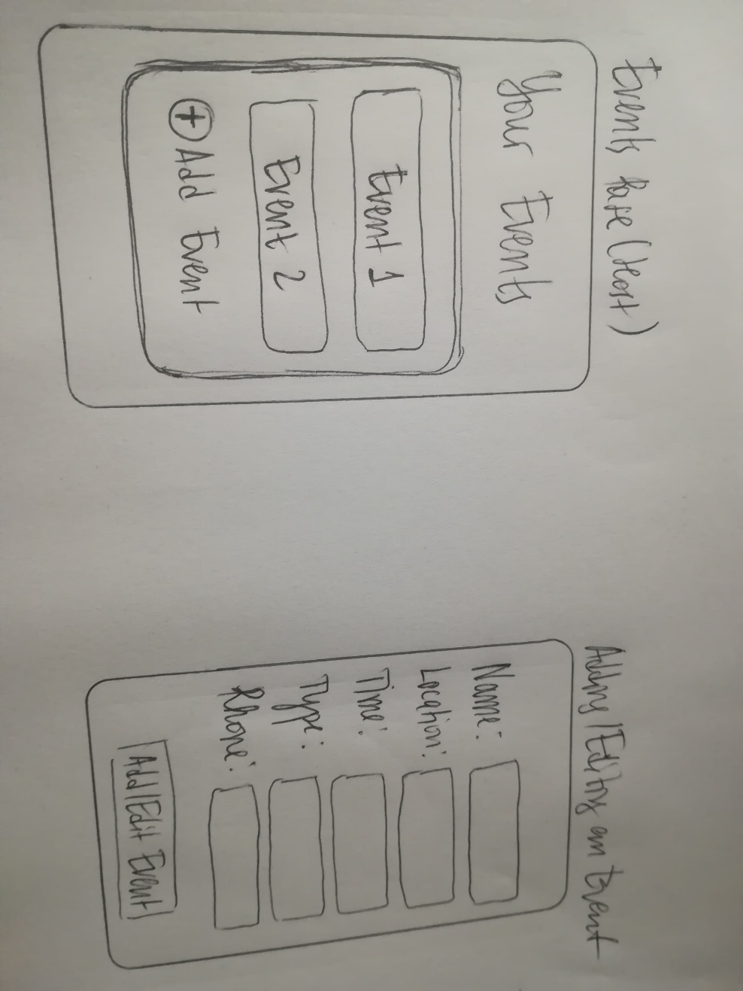

Wireframes

1. Login Page

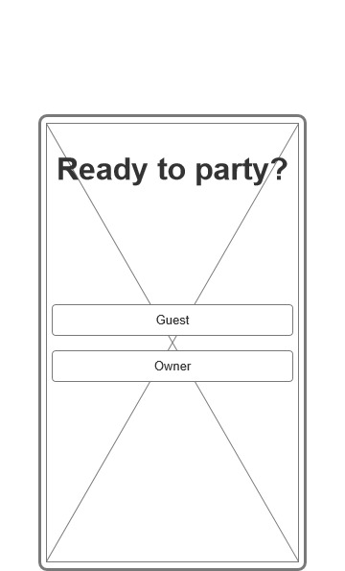

1. Map with events page

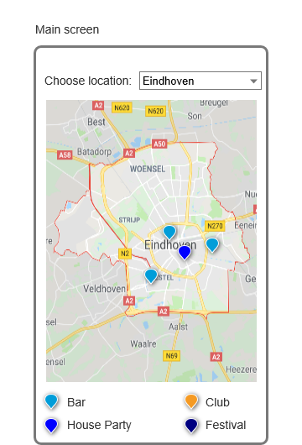

1. Event dialog page

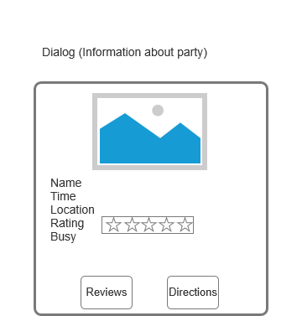

1. Review page

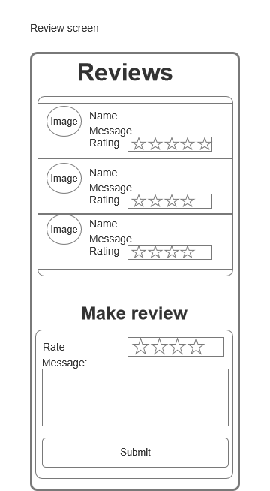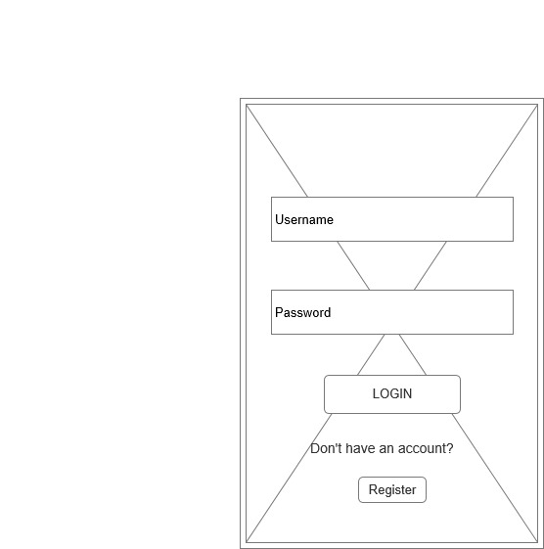5. Host Login page

6. Host registration page

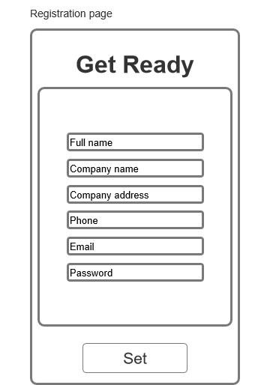7. Host events

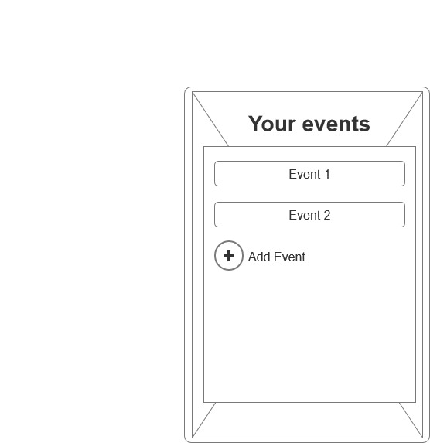8. Host profile page

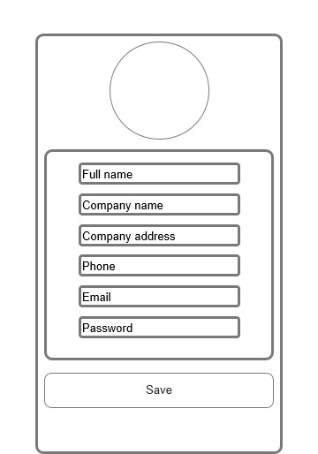

9. Adding event page

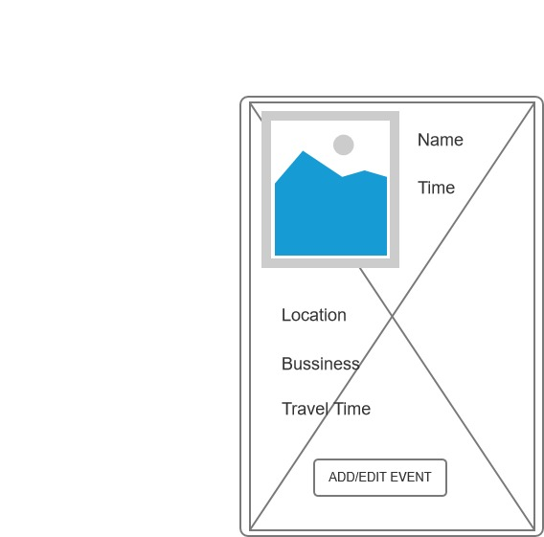

Digital Prototype

